Tuesday – Lesson 2 – What about the Dinosaurs?

Job 40:15a—“Look now at the behemoth, which I made along with you.”

Nothing strikes the imagination like dinosaurs! We all love the thought of dinosaurs stalking and eating people in movies. YUMMY! Evolutionists seek to prove that dinosaurs existed many millions of years ago thus proving the theory of evolution. According to evolutionary theory, dinosaurs and man never existed together and man has never seen a live dinosaur.

PETROGLYH AT NATURAL BRIDGES MONUMENT
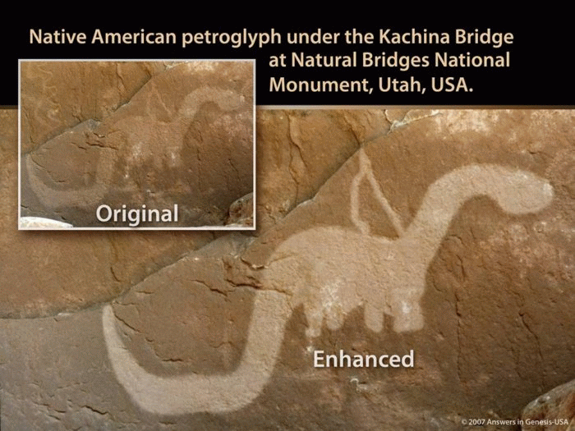

On the underside of the third largest natural bridge in the world (Kachina Bridge) located in the Natural Bridges National Monument just west of Blanding, Utah, are several petroglyphs, which rock-art experts believe to be anywhere from 500 to 1,500 years old. The carvings are thought to be the work of the Anasazi Indians who once lived in the area. A mountain goat, a human figurine, multiple handprints, and many other carvings and drawings are seen quite easily underneath the bridge on both sides of the natural bridge. The most fascinating piece of rock art at Kachina Bridge, however, is the petroglyph of a dinosaur about ten feet up from the ground. This figure carved into the rock has a long thick tail, a long neck, a wide midsection, and a small head. Someone looking at it would have to admit that this petroglyph looks like a dinosaur—specifically an Apatosaurus (more popularly known as Brontosaurus). How did the Anasazi Indians know what it looks like?

ROCK CARVING IN ANCIENT CAMBODIAN TEMPLE
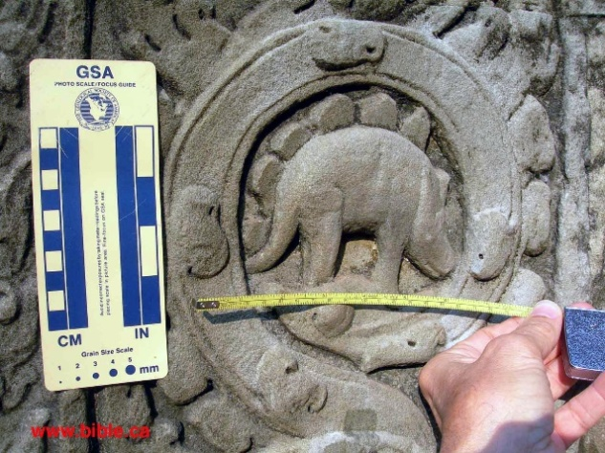

In 1186 AD, King Jayavarman VII built a temple near modern-day Phnom Pehn to honor his mother. Beautiful stone statues and carvings decorate the walls and columns of the temple known as Ta Prohm. Carvings of monkeys, deer, lizards, parrots, swans, and water buffalo are some of the animals shown. On one particular 10-foot column in the temple is a carving of a Stegosaurus. Why is a Stegosaurus carving in an old temple a remarkable thing? Because the temple was built more than 600 years before we learned about dinosaurs from the fossil record. How would these people that carved the temple have known what a Stegosaurus looked like unless they had seen one, or someone had described it to them?
Tuesday – Lesson 2 – What about the Dinosaurs?

ICA BURIAL STONES
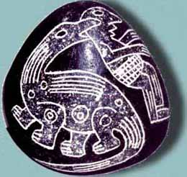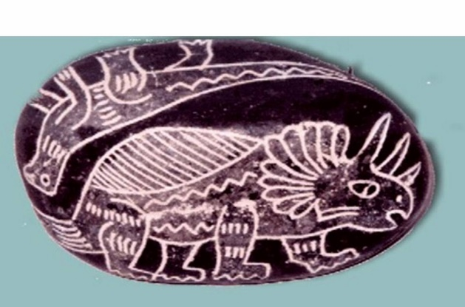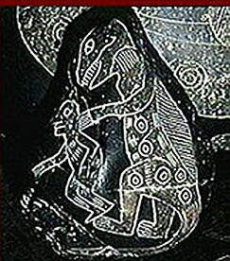

Javier Cabrera Darquea was given a burial stone from the Ica section of the country of Peru for his birthday that he used as a paperweight. Dr. Cabrera eventually gathered over 11,000 of these stones. The rocks were ancient burial stones that the Indians had placed with their dead. Amazingly, almost one-third of the stones showed specific types of dinosaurs such as Triceratops and Stegosaurus and various pterosaurs. The type of art represented by these stones, and their location, dated them to around 500-1500 AD. How could these ancient Indians have known how to draw these creatures if they never had seen them firsthand or were described by someone who had seen them?

Exodus 20:15a—“For in six days the Lord made the heavens and the earth, the sea, and all that is in them, and rested the seventh day.” This one verse should prove to the Christian that dinosaurs once lived with humans.

GOD MADE THE DINOSAURS
In Genesis 1, we find out that all animal life (sea creatures, land animals, and flying creatures) was created on days five and six of Creation. We also learn that God made the first humans, Adam and Eve, on day six. Therefore, if all land animals were created on day six of Creation, and humans also were created on this day, then obviously humans and dinosaurs once lived together.

Does the Bible talk about dinosaurs? Yes! While the Bible does not use the word “dinosaurs”, there are two two impressive animals that God described to Job in chapters 40-41. God describes the behemoth and leviathan. God describes the behemoth as having bones “like bars of bronze and ribs like bars of iron” whose tail “moves like a cedar”. God said the behemoth was “chief of the ways of God”. Leviathan had mighty power, an extremely strong neck, “terrible teeth all around,” tightly joined rows of scales that were almost impenetrable, and a jagged underside that left pointed marks on the ground when it came up on land. Most impressive was its “sparks of fire” from its mouth and “smoke” from its nose.

WHAT HAPPENED TO THE DINOSAURS?
One thing that happened to dinosaurs is the flood in the Bible. Most dinosaur fossils are found in groups together in what appears to be massive flooding. Sudden flash flooding and large amounts of sediment are perhaps the best methods to quickly cover up entire bodies and preserve them. The other thing that may have happened to dinosaurs was they were hunted to extinction, much like the wooly mammoth and many other animals that have been hunted. The North American bison was almost hunted to extinction.

Genesis 9:2-3—“And the fear of you and the dread of you shall be on every beast of the earth, on every bird of the air, on all that move on the earth, and on all the fish of the sea. They are given into your hand. Every moving thing that lives shall be food for you. I have given you all things, even as the green herbs.”

QUESTIONS
1. How have dinosaurs been used to teach evolution?
2. How could people from long ago draw or carve pictures of dinosaurs without seeing them?

