Wednesday – Lesson 2 – The 1st and 2nd Laws of Thermodynamics
Energy exists in many forms, such as heat, light, chemical energy, and electrical energy. Energy is the ability to bring about change or to do work. Thermodynamics is the study of energy.
THE FIRST AND SECOND LAWS OF THERMODYNAMICS
The First Law of Thermodynamics: Energy can be changed from one form to another, but it cannot be created or destroyed. The total amount of energy and matter in the Universe remains constant, merely changing from one form to another. The First Law of Thermodynamics (Conservation) says that energy is always conserved, it cannot be created or destroyed. Energy can be converted from one form into another.
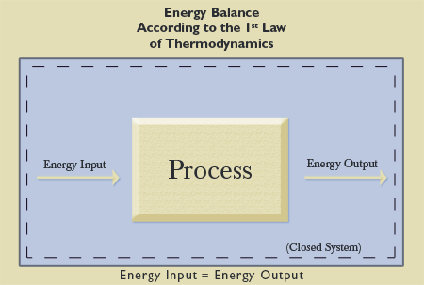
This principle, also known as the “conservation of energy principle” can be demonstrated by the burning of a piece of wood. When the wood is burned, it is transformed into a different state. The original amount of energy present before the burning is still present. However, much of that energy was transformed into a different state, namely, heat. No energy disappeared from the Universe, and no energy was brought into the Universe through burning the wood.
The Second Law of Thermodynamics: In all energy exchanges, if no energy enters or leaves the system, the potential energy of the state will always be less than that of the initial state. This is also commonly referred to as entropy. A spring-driven watch will run until the potential energy in the spring is converted, and not again until energy is reapplied to the spring to rewind it. A car that has run out of gas will not run again until you walk 10 miles to a gas station and fill up the car with gas. Once the potential energy locked in carbohydrates is used as kinetic energy (energy in use or motion), you will get no more energy until you eat again. In the process of energy transfer, some energy will dissipate as heat. Entropy is a measure of disorder. The flow of energy maintains a system. Entropy wins when systems no longer take in energy.
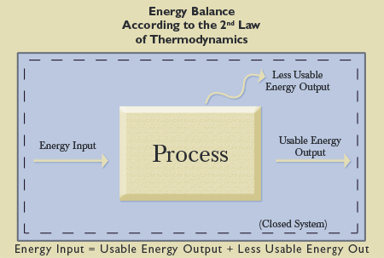
Wednesday – Lesson 2 – The 1st and 2nd Laws of Thermodynamics
In our wood burning illustration, the total amount of energy is still the same after the wood is burned, but transformed into other energy states. Those energy states, ash and the heat given off the fire, cannot be retrieved and returned.

As far as science can tell, its laws have never been violated. They are without exception. From a scientific perspective, the evolutionary model falls short of being able to account for the origin of the Universe. Indeed, it contradicts the known laws of science that govern the Universe. The creation model, on the other hand, is in perfect harmony with the laws of science.

EVOLUTION IS AGAINST THE LAWS OF THERMODYNAMICS
The Second Law of Thermodynamics presents a serious problem for the theory of evolution, because the theory of evolution cannot be true if the Second Law of Thermodynamics is true. George Gaylord Simpson was one of the most famous evolutionists of his day. He said, “Evolution is a fully natural process…by which all living things, past or present, have since developed, divergently and progressively.” He explained that the theory of evolution is supposed to be a process by which things develop progressively. According to evolution, things started out very simple and, over a very long period of time, became increasingly more complex. For instance, a single-celled amoeba supposedly developed into a 100-trillion-celled human over billions of years.

When the theory of evolution is placed beside the Second Law of Thermodynamics, the two don’t agree. Things in this Universe do not get progressively better over time; they get progressively worse (entropy). Every year, we burn resources that can never be replaced. Cars wear out, bodies get old and wrinkly, and buildings deteriorate. If a huge pile of old scrap wood lays in a grassy yard, will it be turned into a nice house if left alone for hundreds of years? Of course not! In fact, anyone who has done his or her homework on the Second Law knows that if things continue as they are, at some point in the future there will be no more usable energy.

This Universe is digressive, not progressive, and that goes directly against the theory of evolution. Creation, on the other hand, falls in line perfectly with the Second Law. In the beginning, God created everything to be very good, but since that time things have deteriorated.

Some engineers devote their entire careers to minimizing entropy in the generation of power from energy. All this effort is based on the principles established by the Second Law of Thermodynamics. These principles are established as fact in the scientific community. The second law of thermodynamics (like every other law of nature) is based on experimental evidence. Every experiment that has been conducted verifies the second law, and no experiment has ever been conducted that contradicts the second law.

IMPLICATIONS OF THE LAWS OF THERMODYNAMICS
When understood properly, the Laws of Thermodynamics apply directly to the creation/evolution controversy in precisely the same way they apply in the engineering world today. In fact, these foundational truths, utilized daily by the engineering world, have eternally significant, spiritual implications in that they prove God exists.

If there is no God, the existence of the Universe must be explained without Him. The Big Bang theory claims that all matter in the Universe initially was condensed in a sphere smaller than the size of a period at the end of this sentence. That sphere exploded and helps to explain why the Universe, according to many cosmologists, appears to be expanding or inflating Even if the Big Bang were true, evolution offers no explanation for the origin of that sphere.

QUESTIONS
1. Where did the little dot that created the “Big Bang” come from?
2. Why would supposed logical scientists ignore the Laws of Thermodynamics to explain Creation?

